**LGS – Gemischte Übungen II**

**Fülle das Kreuzzahlrätsel aus, zuerst die Zahl für x und dann für y.**

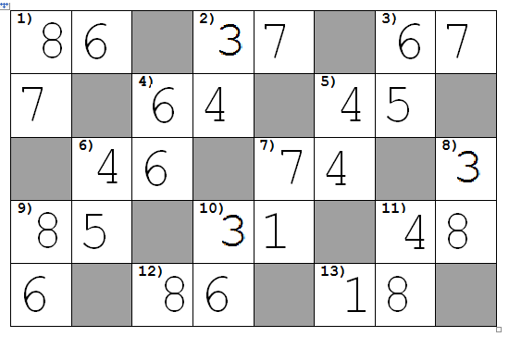

|  |  |
| --- | --- |
| **waagereccht** | **senkrecht** |
| **1) -5x + 3y = -22**  **5x + 2y = 52** | **1) x + 9y = 71**  **-5x – 9y = - 103** |
| **2) -6x + 9y = 9**  **3x + 9y = 90** | **2) -6x + 5y = -34**  **5x + 5y = 65** |
| **3) 9x – 8y = -2**  **-3x + 6y = 24** | **3) -3x + 9y = 27**  **6x + 3y = 51** |
| **4) –x + 4y =10**  **-9x + 4y = -38** | **4) -5x + 4y = -6**  **5x – 4y = 6** |
| **5) -6x – 2y = -34**  **6x + 7y = 59** | **5) -2x + 7y = 20**  **6x - 7y = -4** |
| **6) 6x – 2y = 12**  **7x + 2y = 40** | **6) 2x – 4y = -12**  **2x + 9y = 53** |
| **7) -4x + y = -24**  **8x – y = 52** | **7) 2x + 4y = 18**  **-7x + 5y = -44** |
| **9) 4x + 2y = 42**  **-4x + 6y = -2** | **8) -6x + 7y = 38**  **6x + 9y = 90** |
| **10) 7x + y = 22**  **-7x + 9y = -12** | **9) 6x + 2y = 60**  **5x – 8y = -8** |
| **11) 4x + 4y = 48**  **5x – 4y = -12** | **10)-5x + 3y = 3**  **7x – 3y = 3** |
| **12) 9x + 9y = 126**  **4x + 2y = 44** | **11) x – 6y = -44**  **7x + 3y = 52** |
| **13) x – 4y = -31**  **5x + 3y = 29** |  |